SURESH ANGADI EDUCATION FOUNDATION’S
ANGADI INSTITUTE OF TECHNOLOGY AND MANAGEMENT
Lt. Dr. Suresh Angadi MARG, Savagaon Road, Belagavi – 590 009. (Approved by AICTE, New Delhi &Affiliated to Visvesvaraya Technological University, Belagavi)
Accredited By NAAC & NBA* Department of Computer Science and Engineering Event Report
Report on
Decoding Hackathons & How To Crack A Hackathon
Event conducted on 19th Sept 2025

Guest PRESIDENT
Prof .Sonam Bhandurge Dr. Spoorti R Patil
SPOC AITM COLLEGE PROF. AT CSE DEPT. Director,SAEF

Guest of Honor Conveners
Shri. Raju Joshi Dr.Dhanashree kulkarni
Administrator, SAEF HOD, CSE & Dean Academics
Dr. Anand. B. Deshpande Prof. Gautam Dematti
Principal & Director,AITM Assistant prof, CSE

Content of the Report
1. Introduction
2. Objectives of the Event
3. Relevance to PO
4. Audience Target (Internal or External, Students or Faculty etc.)
5. Speakers
6. Event Proceedings (Guest Talk, Q&A Session & Photo Session)
7. Conclusion

1.INTRODUCTION

This report outlines the fundamentals required to start and run an active ACM (Association for Computing Machinery) student chapter, explains the essentials of hackathons, and provides a concise primer on the Smart India Hackathon (SIH). It is designed for student leaders, faculty advisers, and event organizers who want a practical, actionable guide to build community, host hackathons, and prepare teams for national-level competitions such as SIH.

2.OBJECTIVES
* To introduce students to the vision and activities of the ACM student chapter.
* To build awareness about hackathons as a platform for innovation, collaboration, and problem-solving.
* To familiarize students with the structure, rules, and benefits of participating in hackathons.
* To provide a brief overview of the Smart India Hackathon (SIH), its importance, and how students can participate.
*To encourage teamwork, critical thinking, and technical creativity among students.
*To prepare students for future national-level competitions like SIH through orientation and capacity-building.
* To strengthen the culture of research, innovation, and technical leadership within the institution.

3. Relevance to PO’s :
The following Program Outcomes (POs) are relevant to the event:
• PO10: Communication
• PO12: Life-Long Learning

4. Audience Target :
The audience for this event included students from all departments of Angadi Institute of Technology & Management, along with a few faculty members who participated in the session.

5.SPEAKERS:
* Documentation Head – Miss. Darshana Koli
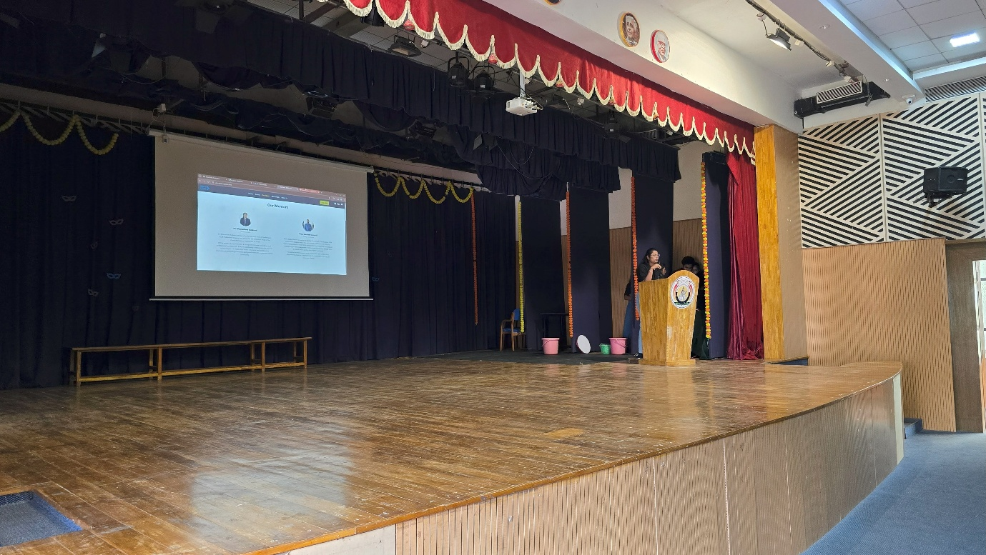
The Association for Computing Machinery (ACM) is the world’s largest professional society in computing, promoting innovation, research, and knowledge sharing. Its student chapters, established in universities and colleges worldwide, create a platform for technical learning and collaboration. The primary vision of an ACM student chapter is to encourage peer mentoring, organize technical events, and foster a culture of innovation and ethical practices.
A typical student chapter is structured with roles such as President, Vice President, Secretary, Treasurer, Event Coordinators, Publicity Leads, and Faculty Advisors, along with committees handling workshops, competitions, and outreach. The chapter regularly organizes activities like technical workshops, coding competitions, hackathons, project showcases, speaker sessions, and mentorship programs. It also conducts outreach initiatives, such as school workshops and community engagement.
For members, participation offers valuable benefits like hands-on skills, teamwork, leadership development, and networking opportunities. For institutions, ACM chapters enhance student engagement, improve placement readiness, and strengthen the overall reputation for innovation and excellence.
*Treasurer – Mr. Ayan Chajju
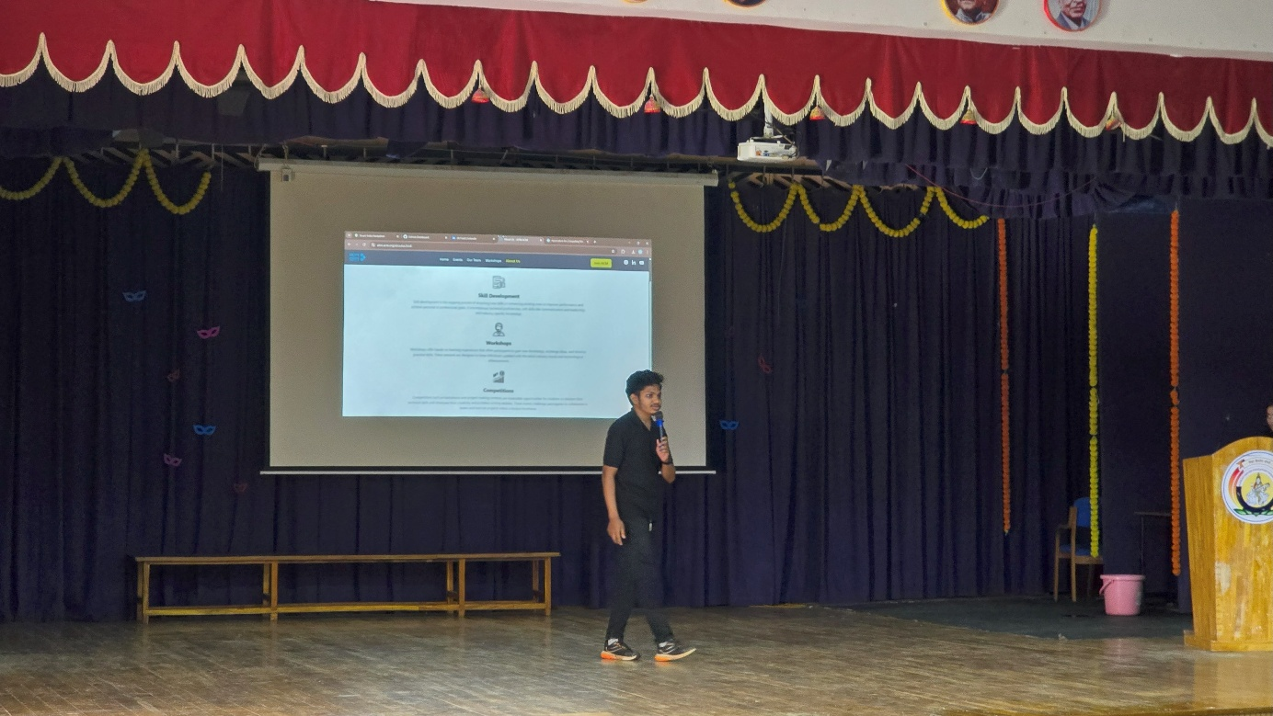
The ACM AITM Student Chapter is a professional student body established under the Association for Computing Machinery (ACM), the world’s largest computing society. Our chapter at AITM serves as a vibrant hub for students passionate about technology, research, and innovation.
Through workshops, hackathons, coding competitions, seminars, and community-driven projects, ACM AITM empowers students to develop technical skills, explore cutting-edge domains, and connect with industry experts. The chapter also focuses on bridging the gap between academia and industry by organizing guest lectures, career sessions, and collaborative projects.

*Webmaster Head – Miss. Khatija Dalawai
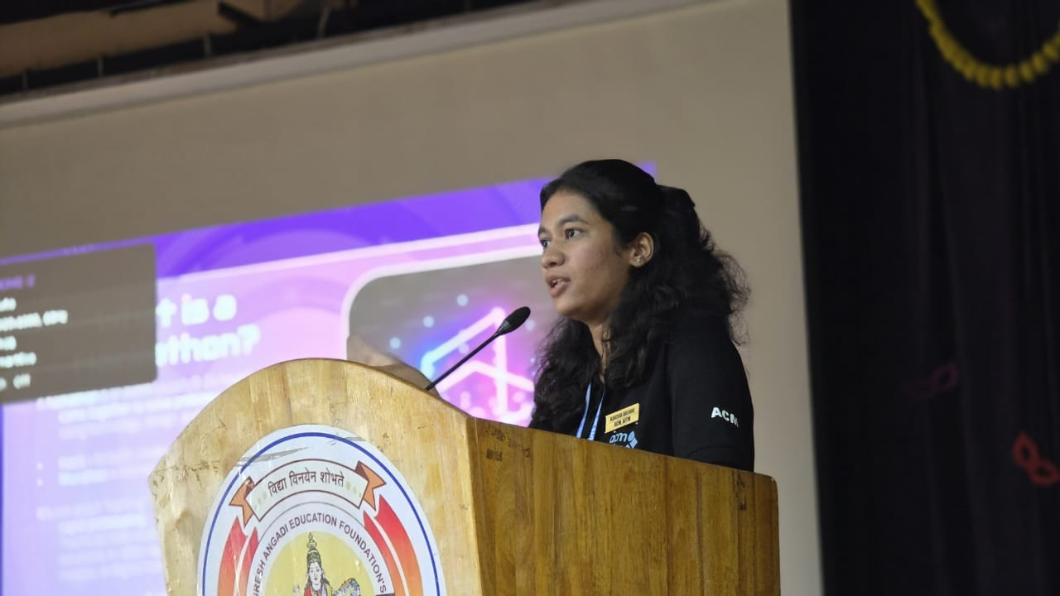
A hackathon is a short, intensive event where teams collaborate to design, prototype, and present solutions to specific problems, focusing on innovation, teamwork, and rapid development.The lifecycle of a hackathon typically includes announcement and registration, team formation and ideation, development, mentorship checkpoints, final submission and presentation, followed by judging and awards. Judging criteria often emphasize innovation, technical execution, usability, feasibility, and the quality of the presentation.
Participants must follow rules such as originality of code, adherence to time limits, team size restrictions, and hardware/software guidelines. To succeed, teams use popular tools and technologies like GitHub, cloud platforms, web and mobile frameworks, Python for data science, and collaboration platforms like Slack or Notion.
Effective participation requires forming a balanced team, prioritizing a minimum viable product (MVP), using version control, preparing a concise demo, and leveraging mentors for guidance. Quick prototyping methods and clear pitches greatly improve chances of success
*Vice Chair – Miss. Pragati Gangoji
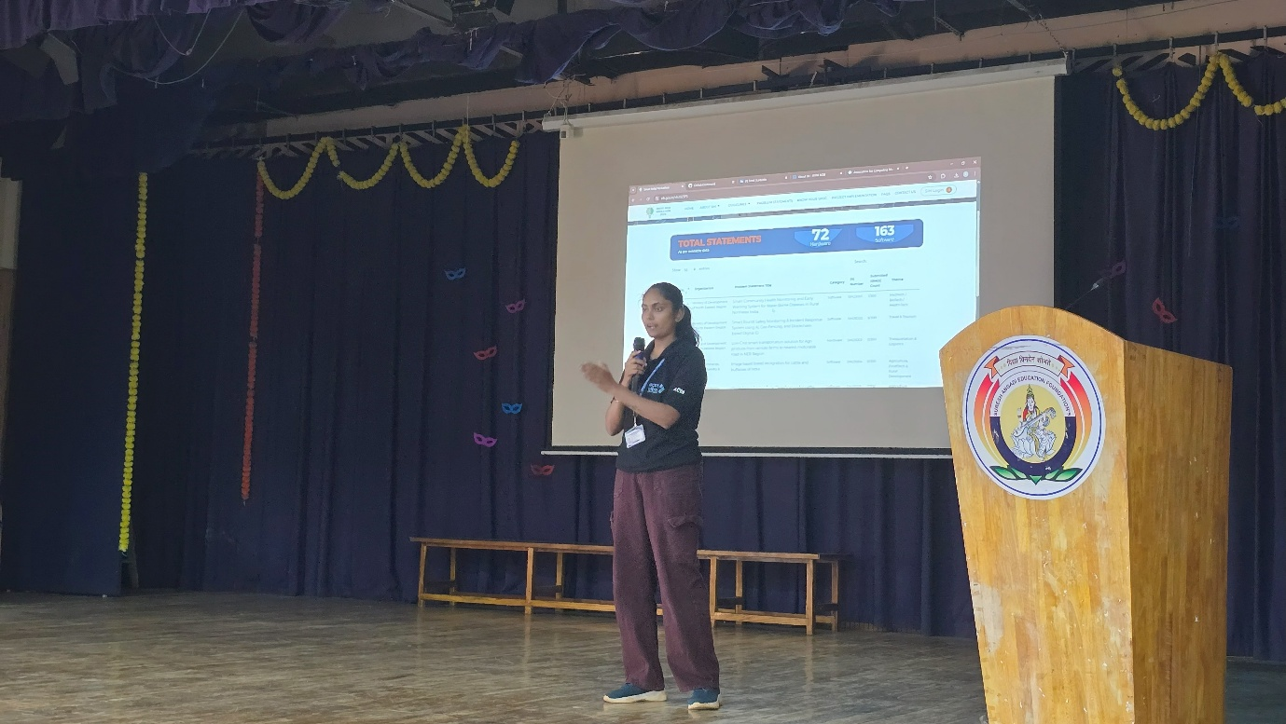
Smart India Hackathon (SIH) is a nationwide initiative by the Government of India to empower students to solve real-world problems faced by government and industry. It promotes innovation, collaboration, and strong partnerships between academia, industry, and government SIH provides students with exposure to large-scale evaluation and pathways for real implementation. Problem statements are released by ministries, PSUs, and companies; teams select and compete through online and onsite rounds. Preparation strategies include aligning problems with team strengths, building proof-of-concepts early, documenting designs, and planning scalability. To host a hackathon, an ACM chapter should follow an 8–10 week timeline from planning and sponsorship outreach to execution and reporting. Clear roles such as Event Lead, Technical Lead, Finance, Operations, and Publicity ensure smooth functioning. Effective promotion through posters, social media, alumni networks, and webinars helps maximize participation and impact.
* Sonam Bhandurge -SPOC AITM COLLEGE PROF. AT CSE DEPT.
Smart India Hackathon (SIH) at our institution, I am proud to introduce this national initiative by the Government of India. SIH provides students with a platform to solve real-world problems from ministries, industries, and society, making it one of the largest innovation-driven hackathons in the world.
Through SIH, students work in teams to design prototypes, gain mentorship from experts, and present their solutions at a national level. The event not only encourages innovation and teamwork but also builds strong links between academia, industry, and government.
Our role is to guide and support teams so they can showcase their talent, creativity, and problem-solving skills, contributing to impactful solutions for the nation.
6. Event Proceedings

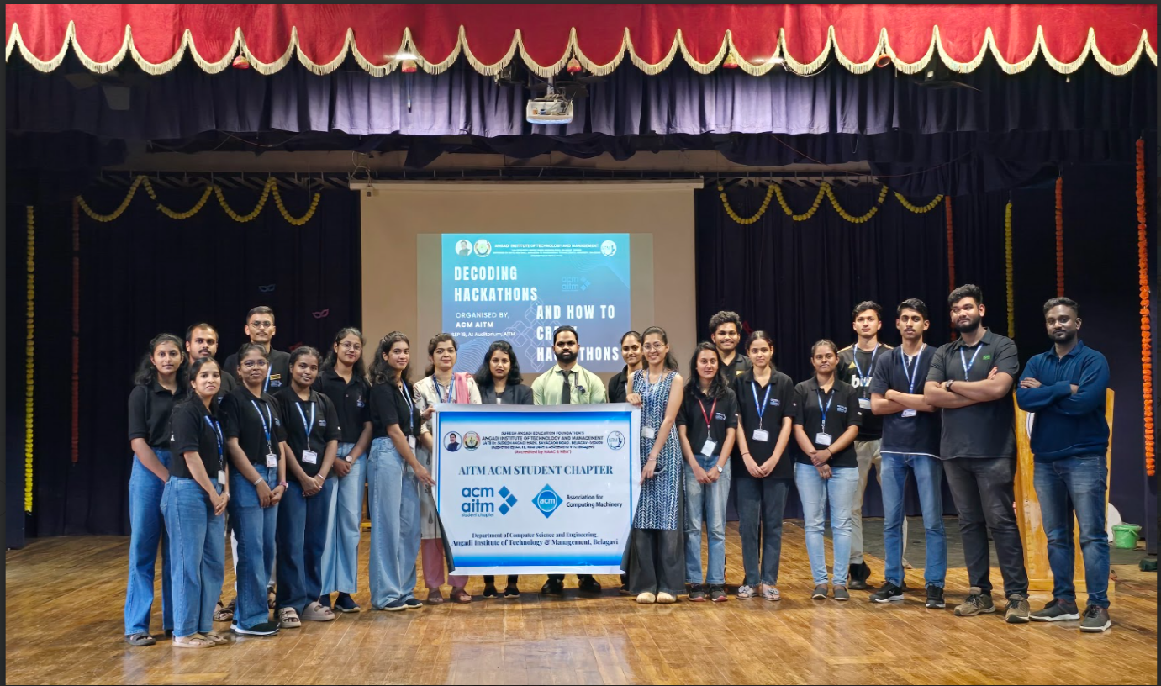

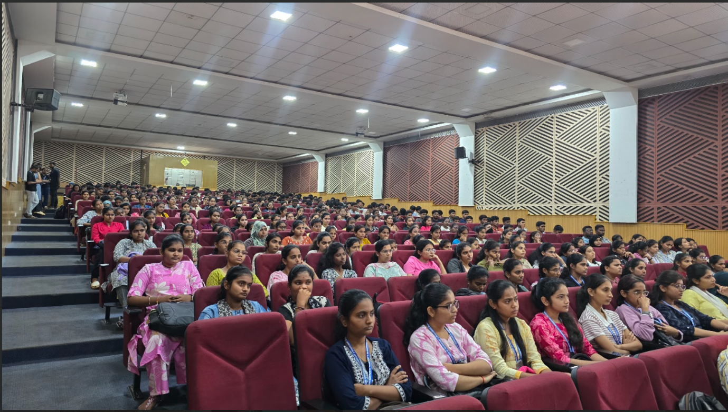

7. Conclusion
An active ACM chapter is a catalyst for innovation, professional development, and community-building within an institution. Hosting hackathons—whether small campus events or preparing teams for SIH—helps students gain real-world problem-solving experience, teamwork skills, and industry exposure. With clear planning, balanced teams, and strong mentorship, student chapters can create sustained impact and launch high-quality projects that address real challenges.

